Strategy Guide — Tourism use of this procedure
The procedure is: check logistic assumptions → fit a binary logit → move the threshold → read the ROC → handle class imbalance. It is a scoring workflow for a 0/1 tourism event, not a demand forecast and not a causal study of why guests cancel.

When this package is the right next step
- The event is a clean 0/1 (cancel / stay, book / abandon) and you can name the costly error.
- Features are numeric or flags with a roughly linear log-odds.
- You want coefficients a revenue meeting can read.
- n is hundreds+ and the minority class still clears ~10 events per planned feature.

Top 10 tourism applications
- Hotel / OTA booking-cancellation scoring (this notebook).
- Tour-package website conversion (the practice file).
- Attraction or restaurant no-show from party size + lead time + channel.
- Repeat-visit or loyalty-enrolment propensity after a stay.
- Ancillary upsell accept vs decline (spa, transfer, breakfast).
- Package abandon at the payment step.
- Destination-recommendation click on a DMO site.
- Review-invite response (will this guest leave a review?).
- Group-booking confirm vs release as the cut-off date approaches.
- Weather-sensitive outdoor activity attendance go / no-go.

When it is not appropriate
- Choosing among many destinations — ranking / multinomial, not binary logit.
- Repeated stays by the same loyalty member without a clustered model.
- A boutique inn with 40 labelled cancels and 15 features — EPV collapse.
- Raw clickstream columns — learn a representation first.
- Causal claim that a deposit policy “caused” cancels — this is a risk score.
- Daily occupancy level forecasting — that is a time series.
- Strong seasonality with no calendar features and no refit.
- Length-of-stay or spend as the real target — use regression / duration models.

How to reuse the template
Open LogReg_Tour_Reusable_Template.ipynb. Change DATA_PATH, TARGET, POSITIVE_MAP, FEATURES, ID_COL, THRESHOLD. Run the assumption cells before you celebrate the AUC. Copy the simulation cell when a GM asks “what if we only labelled 200 bookings?”.

Responsible use
tour_hotels.csv is a teaching proxy generated so the lesson numbers are stable. It is not last night’s PMS extract and it is not a licence to auto-cancel a reservation. Thresholds belong to the people who own empty-room cost and guest goodwill. Write “decision support, not a verdict” on every memo that leaves the classroom.
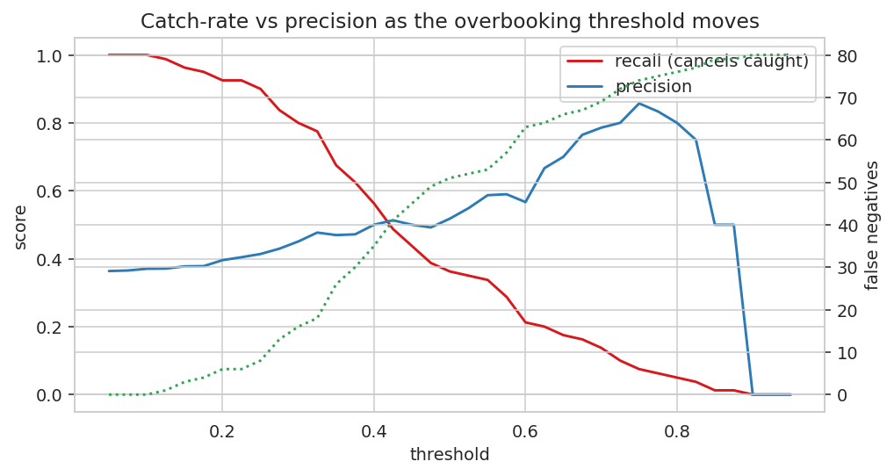
Catch-rate falls and precision rises as the cut moves right; missed cancels (dotted) climb. That picture is the whole overbooking conversation.

